**PYTHON ASSIGNMENT – 5**

**Q1. Hint:**

**-> Make a use of Time Module and for Loop**

**-> Output Should be :**

**Loading.**

**Loading..**

**Loading...**

**Loading....**

**Loading.....**

**Here it shows you 5 output but you have to print only "Loading....." in animated form.**

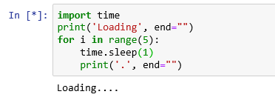

**Q2. Difference between Return and Yield?**

The yield statement suspends function’s execution and sends a value back to the caller, but retains state so function resumes where it is left off. Hence, the code produces a series of values over time, rather than computing them at once and sending them back like a list or a tuple. Yield are used in Python generators.

Return sends a specified value back to its caller.

**Q3. Make digital Clock and run it for 5 sec.**

**Output:**

**16:39:08**

**:09**

**:10**

**:11**

**:12**

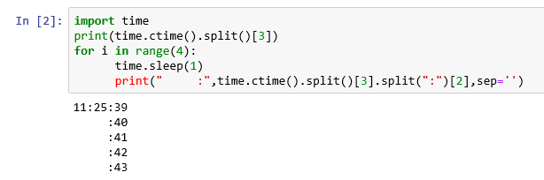

**Q4. Add anything in tuple.. example: (1,2,3,4) -> new tuple (1,2,3,4,5)**

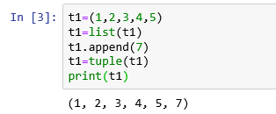

**Q5. WhatsApp texting using webbrowser Lib.**

